

Exp 1: analyses and development and verification of 8 bit and 16 bit arithmetic operations using assembly language program

OBJECTIVES
- To analyse and verify 8-bit addition and subtraction using an 8-bit microprocessor.
- To analyse and verify 16-bit addition and subtraction using an 8-bit microprocessor.
- To analyse and verify 8-bit multiplication and division using an 8-bit microprocessor.
- To analyse and verify 16-bit multiplication and division using an 8-bit microprocessor.

Components required:
8085 simulator
Procedure:
1.Switch ON the microprocessor kit.
2.Enter the starting memory address of the program.
3.Enter the required 8085 assembly language instructions one by one.
4.Enter the input data at the specified memory locations.
5.Execute the program from the starting address.
6.Check the output stored in the specified memory location.
7.Verify the result with the expected output.
8.Switch OFF the microprocessor kit after completing the experiment.

1. (i) To analyse and verify 8-bit addition using 8 bit microprocessor.

PROGRAM:
MVI C 00h
LDA 4200h
MOV B A
LDA 4201h
ADD B
JNC SKIP
INR C
SKIP: STA 4202h
MOV A C
STA 4203h
HLT
OUTPUT:
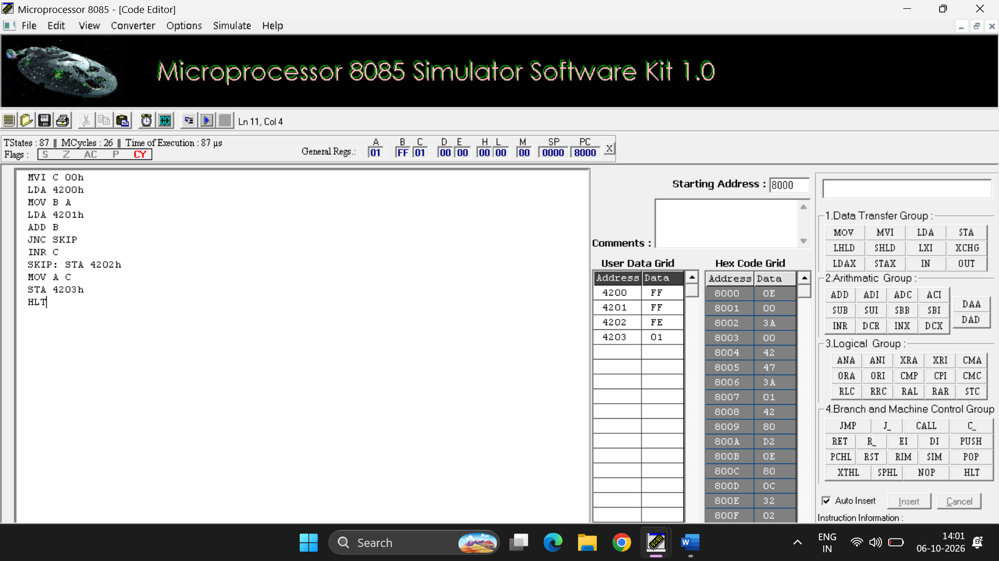

ADDRESS | DATA
4200 | FF
4201 | FF
4202 | FE
4203 | 01

(ii) To analyse and verify 8-bit subtraction using 8 bit microprocessor.

PROGRAM:

MVI C 00h
LDA 4201h
MOV B A
LDA 4200h
SUB B
JNC SKIP
CMA
INR A
INR C
SKIP: STA 4202h
MOV A C
STA 4203h
HLT

OUTPUT:
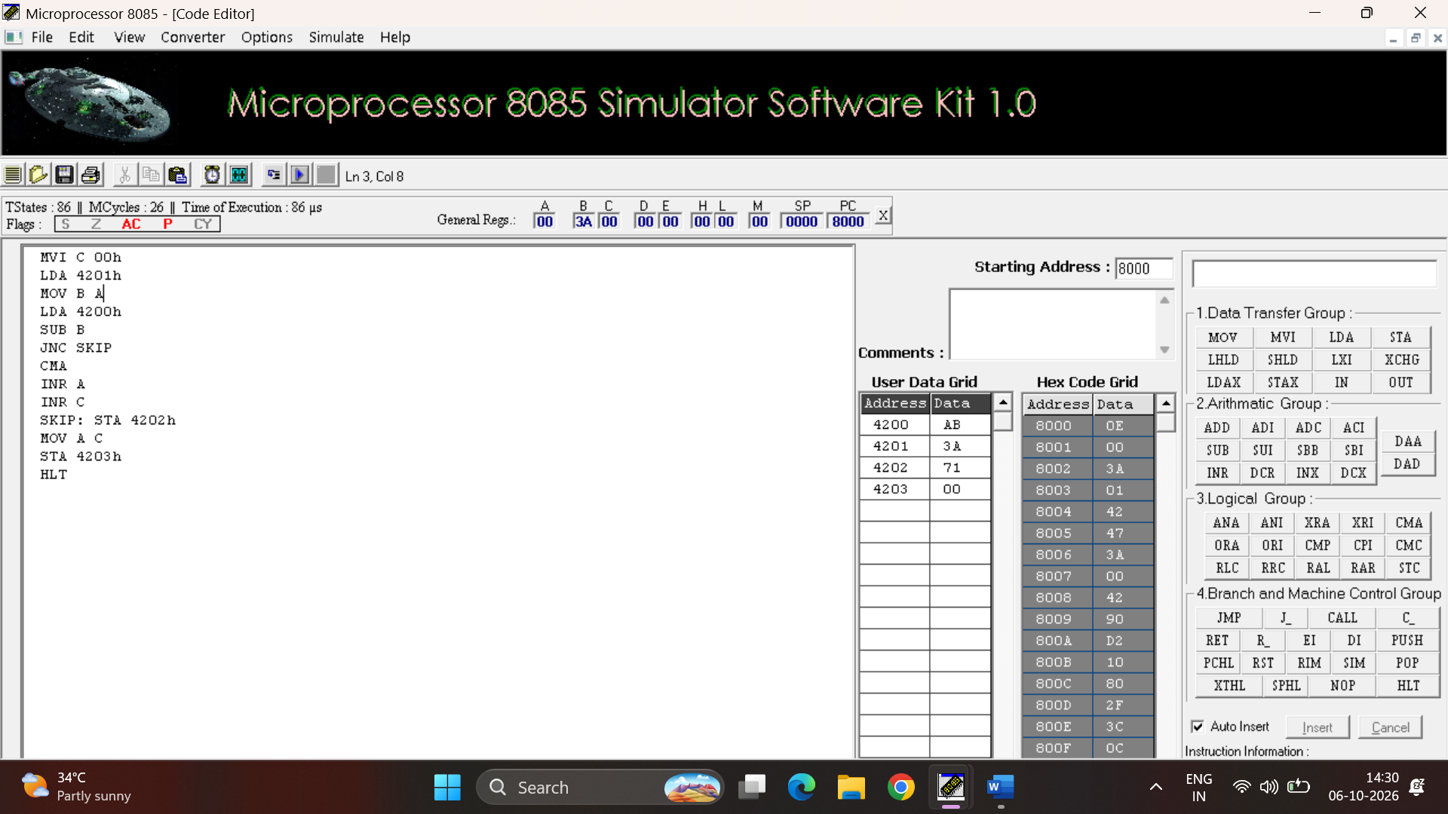

ADDRESS | DATA
4200 | AB
4201 | 3A
4202 | 71
4203 | 00

RESULT:
Thus, 8-bit addition and subtraction were performed and verified successfully using the 8085 microprocessor.

2. (i) To analyse and verify 16-bit addition using 8 bit microprocessor

PROGRAM:

MVI C 00h
LHLD 4000h
XCHG
LHLD 4202h
DAD D
JNC SKIP_CARRY
INR C
SKIP_CARRY: SHLD 4004
MOV A C
STA 4006h
HLT

OUTPUT: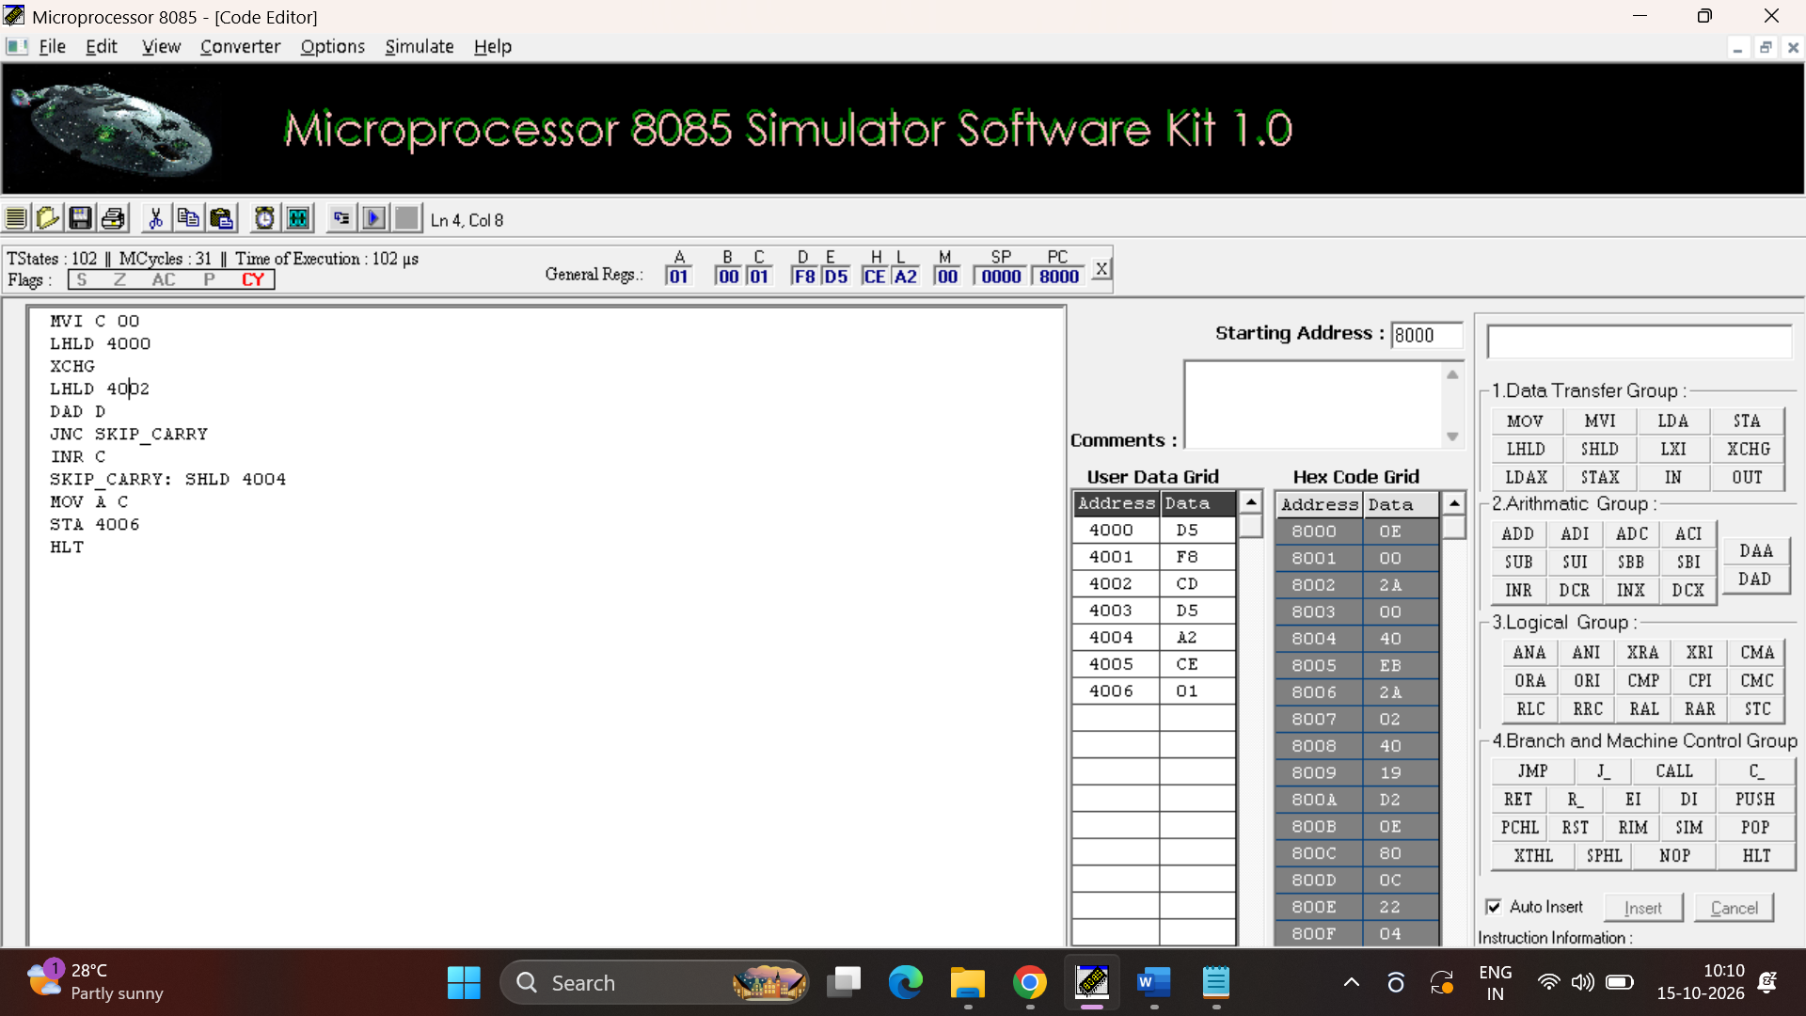

ADDRESS | DATA
4000 | D5
4001 | F8
4002 | CD
4003 | D5
4004 | A2
4005 | CE
4005 | 01

(ii) To analyse and verify 16-bit subtraction using 8bit microprocessor

PROGRAM:

MVI C 00
LHLD 4000
MOV A L
LHLD 4002
SUB L
MOV L A
MOV A H
SBB H
MOV H A
JNC SKIP_BORROW
INR C
CMA
MOV H A
MOV A L
CMA
ADI 01
MOV L A
MOV A H
ACI 00
MOV H A
SKIP_BORROW: SHLD 4004
MOV A C
STA 4006
HLT

OUTPUT:
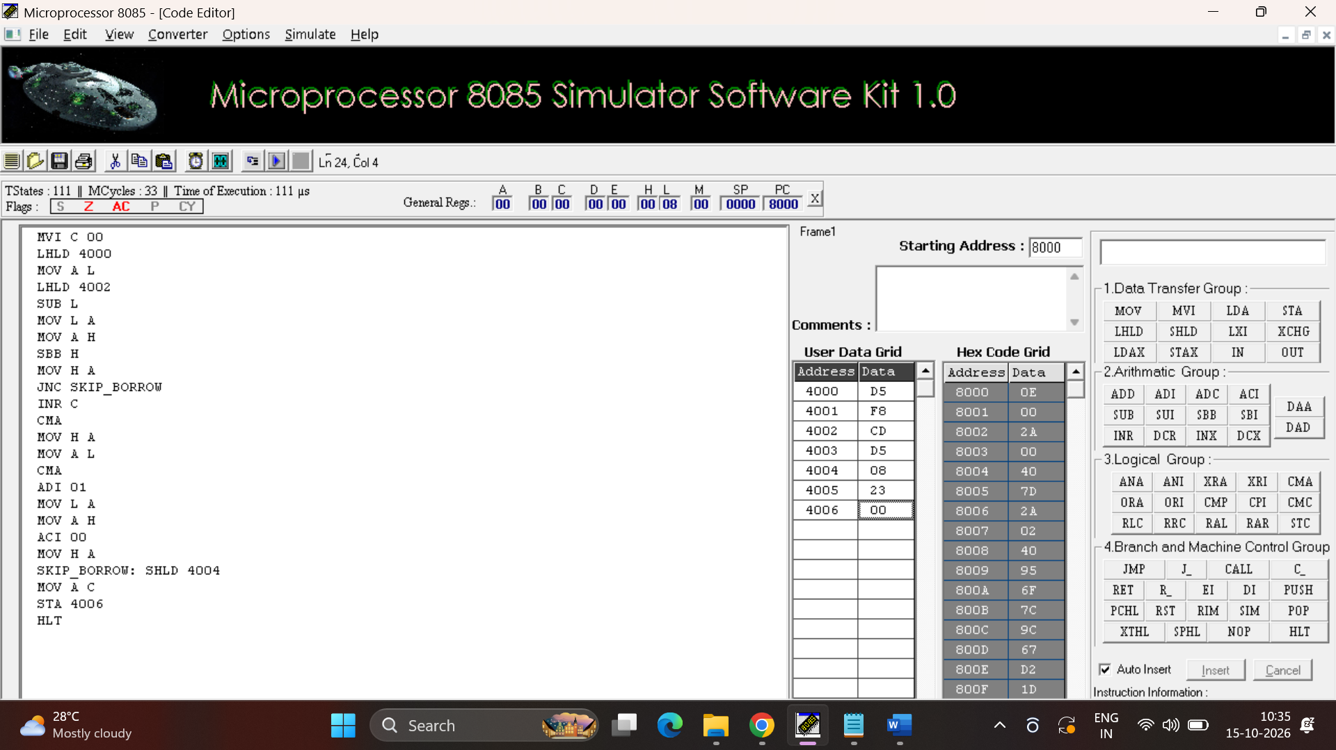

ADDRESS | DATA
4000 | D5
4001 | F8
4002 | CD
4003 | D5
4004 | 08
4005 | 23
4006 | 00

RESULT:
Thus, 16-bit addition and subtraction were performed and verified successfully using the 8085 microprocessor.

3. (i) To analyse and verify 8-bit multiplication using 8 bit microprocessor

PROGRAM:

LDA 4200h
MOV E A
LDA 4201h
MOV B A
LXI H 0000h
MVI D 00h
NEXT: DAD D
DCR B
JNZ NEXT
SHLD 4202h
HLT

OUTPUT:
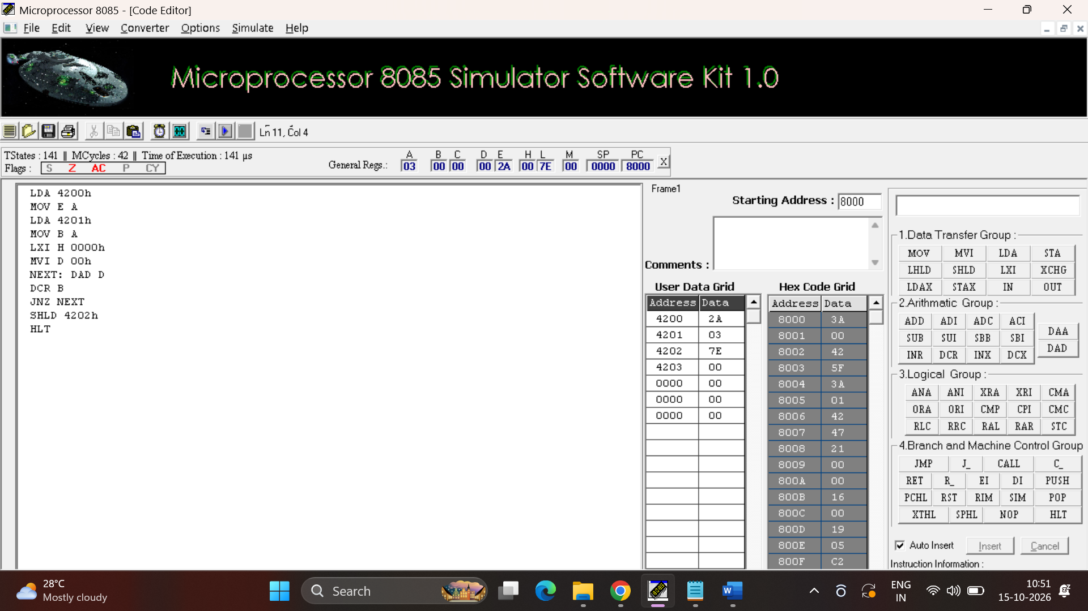

ADDRESS | DATA
4200 | 2A
4201 | 03
4202 | 7E
4203 | 00

(ii) To analyse and verify 8-bit division using 8 bit microprocessor.
PROGRAM:

LXI H 2050h
MOV A M
INX H
MOV B M
MVI C 00h

LOOP: CMP B
JC DONE
SUB B
INR C
JMP LOOP

DONE: STA 2052h
MOV A C
STA 2053h
HLT

OUTPUT:

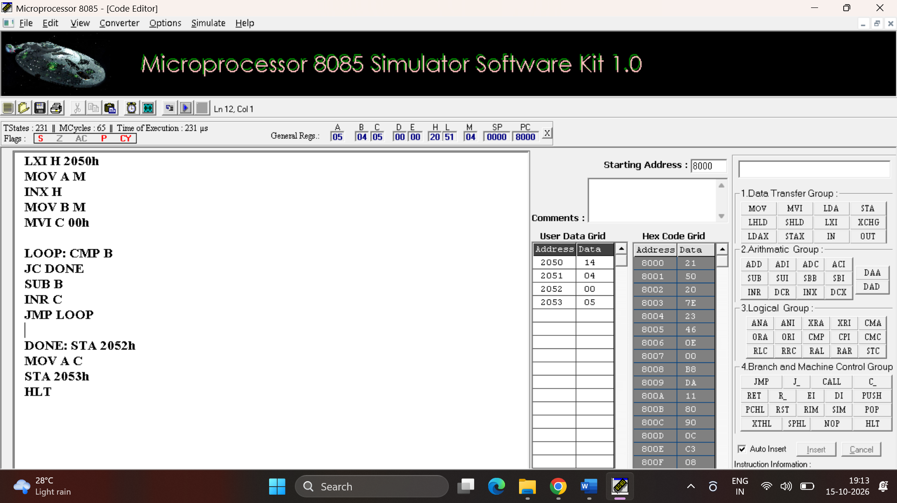

ADDRESS | DATA
2020 | 14
2051 | 04
2052 | 00
2053 | 05

RESULT:
Thus, 8-bit multiplication and division were performed and verified successfully using the 8085 microprocessor.

4.(i) To analyse and verify 16bit multiplication using 8bit microprocessor

PROGRAM:

LXI H 2050h
MOV E M
INX H
MOV D M

LXI H 2052h
MOV C M
INX H
MOV B M

LXI H 0000h

LOOP: DAD D
DCX B
MOV A B
ORA C
JNZ LOOP

SHLD 2054h
HLT

OUTPUT:

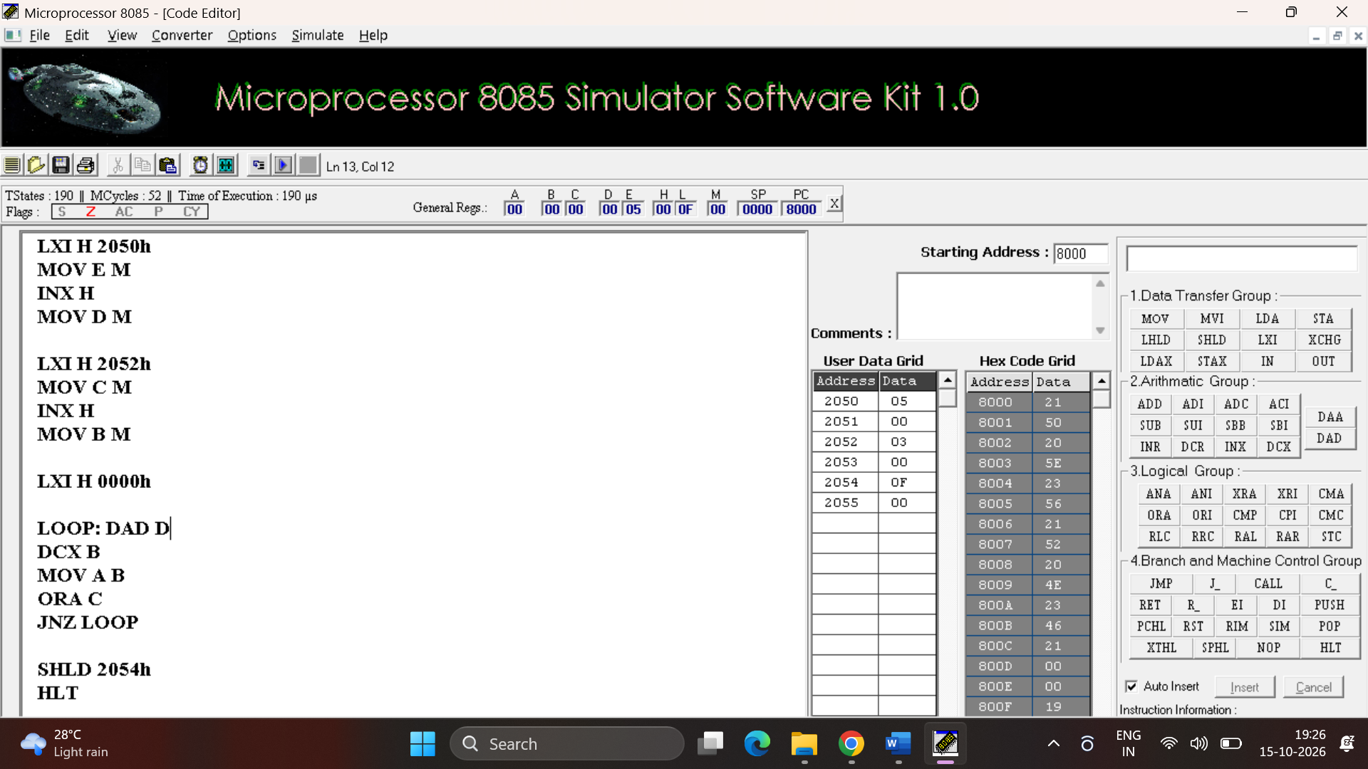

ADDRESS | DATA
2050 | 05
2051 | 00
2052 | 03
2053 | 00
2054 | 0F
2055 | 00

(ii) To analyse and verify 16-bit division using 8bit microprocessor.

PROGRAM:

LXI H 2050h
MOV E M
INX H
MOV D M

LXI H 2052h
MOV C M
INX H
MOV B M

MOV A B
ORA C
JZ STOP

LXI H 0000h

LOOP: MOV A E
SUB C
MOV A D
SBB B
JC DONE

MOV A E
SUB C
MOV E A
MOV A D
SBB B
MOV D A

INX H
JMP LOOP

DONE: SHLD 2054h
XCHG
SHLD 2056h
HLT

STOP: HLT

OUTPUT:

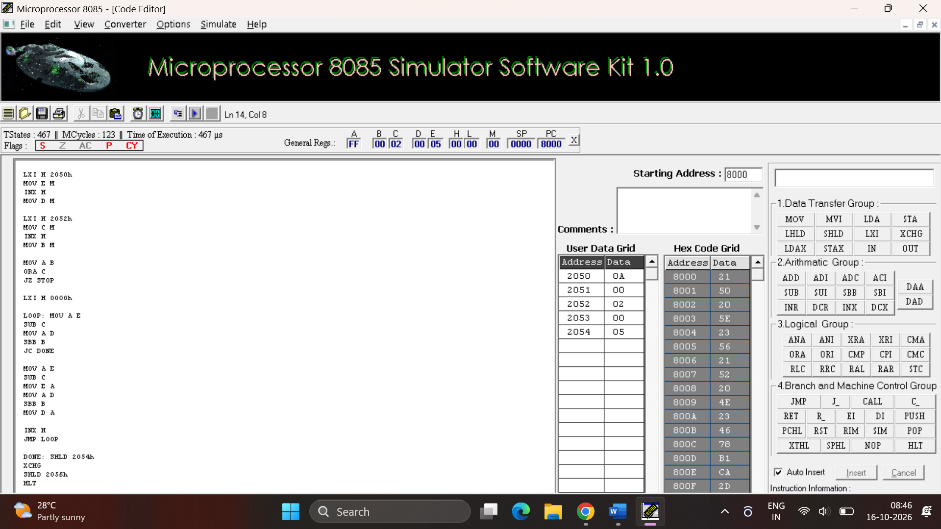

ADDRESS | DATA
2050 | 0A
2051 | 00
2052 | 02
2053 | 00
2054 | 05

RESULT:
Thus, 16-bit multiplication and division were performed and verified successfully using the 8085 microprocessor.

